Day 16 Angular Introduction
Angular Framework official Site -- https://angular.dev/ (v21)
Angular is a Open Source JS based Front end framework created by google.
Library – It’s solves a particular challenge.
Framework – Is a collection of libraries & tools which aims to managing entire application.

Popular JS based libs & frameworks
- React – library
- Angular – Framework
- Vue Js
- Next JS – Framework based on React.

Run the JS code outside the browser. NodeJS.
SPA – Single Page Application.
Earlier days website is a combination of multiple web pages.
Company-site.html - index.html (home.html), aboutus.html, service.html, contactus.html, feedback.html, clients.html [Multi-Page Application] Sync/Blocking mode.
AJAX – Asynchronous Javascript And XML (XmtHttpRequest) – Which will be helpful to do non-blocking or async communication between client & server.
Only one Page – index.html -- Components (Reusable piece of UI)
Web Page – HTML, CSS, JS – aboutus.html, contactus.html
Component – HTML, CSS, JS – app.ts/app.js (Java script & typescript is supported) – aboutus.ts, contactus.ts –

Creating custom HTML tags.
In HTML, tags are pre-defined. <html> <h1>

Live Reloading.

Using Angular PlayGround in angular.dev website.

- GUI Mode – Graphical User Interface
- CUI Mode – Character User Interface (commands knowledge is mandatory)
Create new Angular application locally with Angular CLI. (Command line interface)
Open VS Code IDE’s terminal (command prompt)
- “node -v”
- “npm -v”
- Installing Angular CLI as global package. “npm I -g @angular/cli”
- “ng v”
- “ng new my-app”
- “cd my-app”
- “ng serve” – Open http://localhost:4200 in browser

Arch of Angular Application
- Public (f) – favicon.ico
- Src (f) -index.html, main.ts, style.css, app(f) – app.html, app.css, app.ts, app.spec.ts (unit test)
- Package.json
- Tsconfig.json

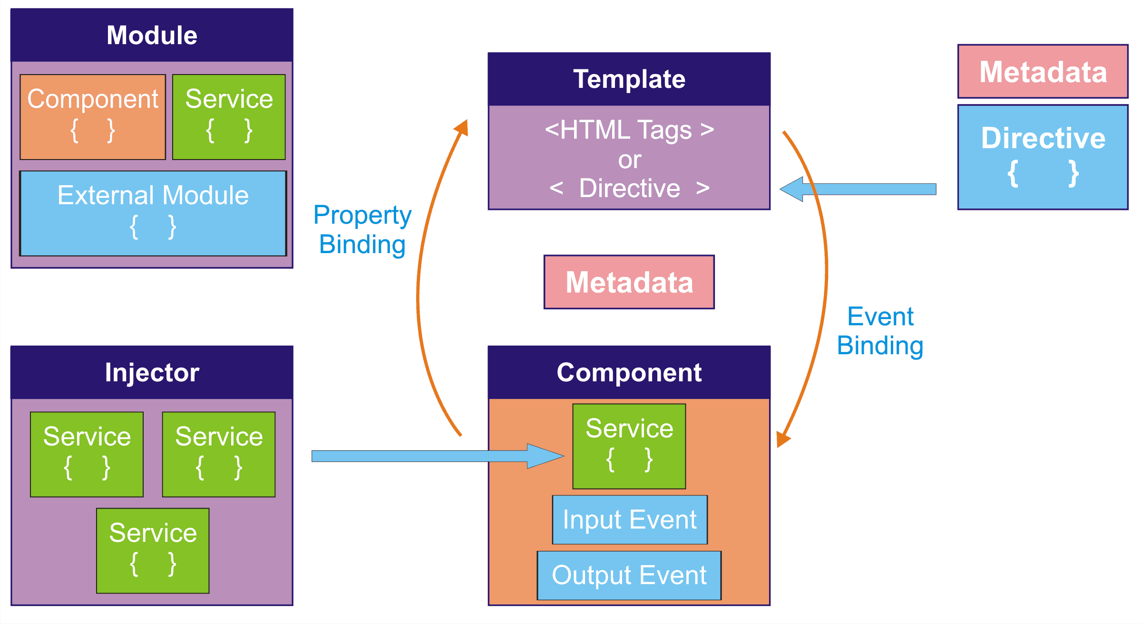
JS – Revisit
Types of Variables (scope)
- Global variables
- Local variables
Types of variable (Usage)
- Local/Arguments/Parameters
- Instance variables
Types of Classes
- Normal Class
- Anonymous (nameless) Class
- Class assigned to a const or Class Expression
// Declaration
class Rectangle {
constructor(height, width) {
this.height = height;
this.width = width;
}
}

// Expression; the class is anonymous but assigned to a variable
const Rectangle = class {
constructor(height, width) {
this.height = height;
this.width = width;
}
};

// Expression; the class has its own name
const Rectangle = class Rectangle2 {
constructor(height, width) {
this.height = height;
this.width = width;
}
};

https://developer.mozilla.org/en-US/docs/Web/JavaScript/Reference/Classes
https://www.typescriptlang.org/docs/handbook/typescript-in-5-minutes.html
https://www.typescriptlang.org/docs/handbook/decorators.html

Typescript Decorators (Meta-Data)
Decorators always start with @ symbol. -- @component, @Service,

Decorators
A Decorator is a special kind of declaration that can be attached to a class declaration, method, accessor, property, or parameter. Decorators use the form @expression, where expression must evaluate to a function that will be called at runtime with information about the decorated declaration.
For example, given the decorator @sealed we might write the sealed function as follows:
function sealed(target) {
// do something with 'target' ...
}

Syntax for creating new component
“ng g (generate) c (component) <component-name>”
4 files will be created .html (component-level view), .css (component-level style info), .ts, .spec.ts (unit test)

“ng g c <comp-name> --inline-style --inline-template (comp.ts, comp.spec.ts)

`Welcome to {{city}} ` = Template Literal
{{}} – component binding

Binding
- Property binding (variable)— {}
- Method binding (function/method) - []
- Two way binding – [{}] – Banana in a box
Component – [view, data, style] – [html, ts/js, css]
{{}} – interpolation [Used for evaluating expressions or binding properties.

Conditional Rendering.

Rendering – It’s a process of reading all the HTML tags and displaying the elements accordingly in the viewport.
Parsing – Extracting data (xml, json)
Browser
- HTML rendering Engine
- CSS styling Engine
- JS Runtime Engine

